Zadatk 1.a)
______________________________________________________________________________________________________________________________________________________________________________________________________________________________________________________
t=-3*pi:0.01:3*pi;  x1=2*cos(3*t)+3*sin(2*t);  plot(t,x1);  xlabel('t');  ylabel('x1(t)'); | 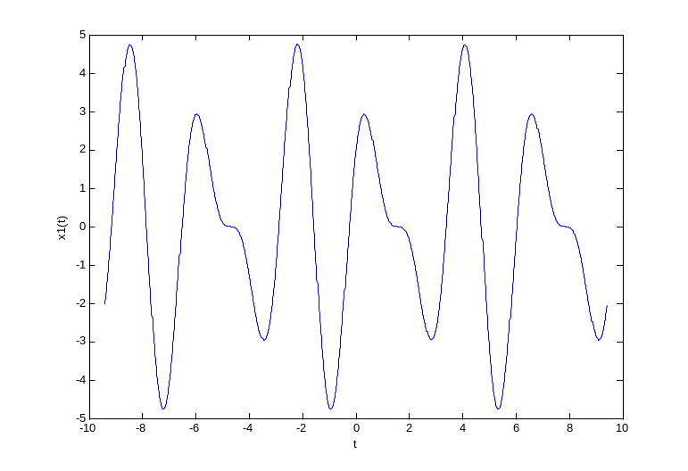

Zadatak 1.b)
______________________________________________________________________________________________________________________________________________________________________________________________________________________________________________________
t=-pi:0.01:pi;  x2=abs(exp(j*4*t)+exp(j*11*t));  plot(t,x2);  xlabel('t');  ylabel('x2(t)'); | 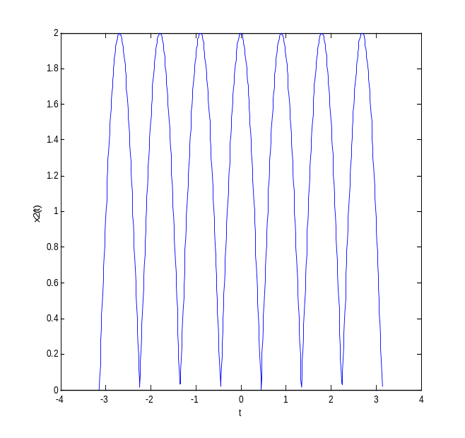

Zadatak 2.a)
______________________________________________________________________________________________________________________________________________________________________________________________________________________________________________________
n=-20:20;  x1=5*sin((pi*n)/8);  stem(n,x1);  xlabel('n');  ylabel('x1[n]'); | 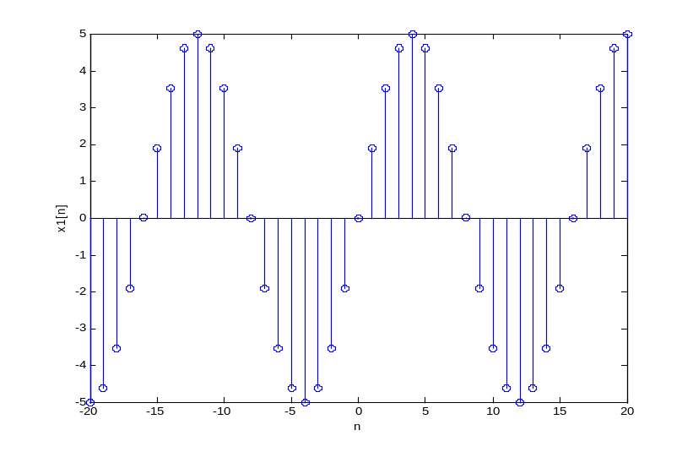

Zadatak 2.b)
______________________________________________________________________________________________________________________________________________________________________________________________________________________________________________________
n=-20:20;  x2=u(n);  stem(n,x2);  xlabel('n');  ylabel('x2[n]'); | 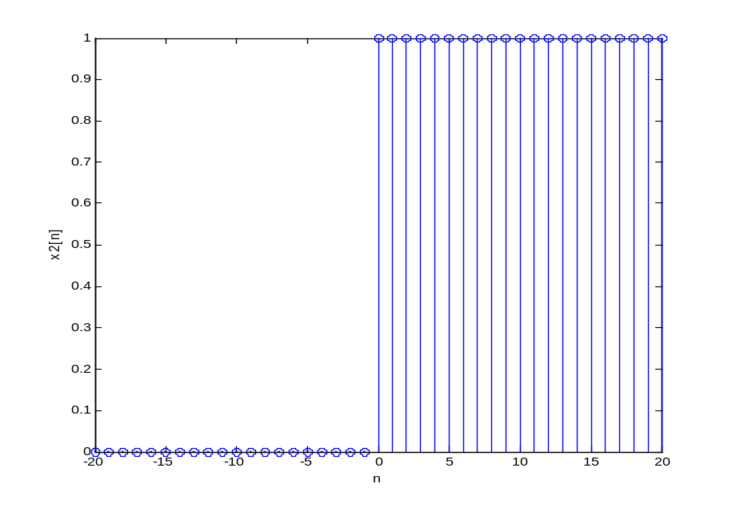

Zadatak 2.c)
______________________________________________________________________________________________________________________________________________________________________________________________________________________________________________________
n=-20:20;  x3=d(n+3)+2*d(n+1)-4*d(n)+  d(n-2)-6*d(n-4)+5*d(n-5);  stem(n,x3);  xlabel('n');  ylabel('x3[n]'); | 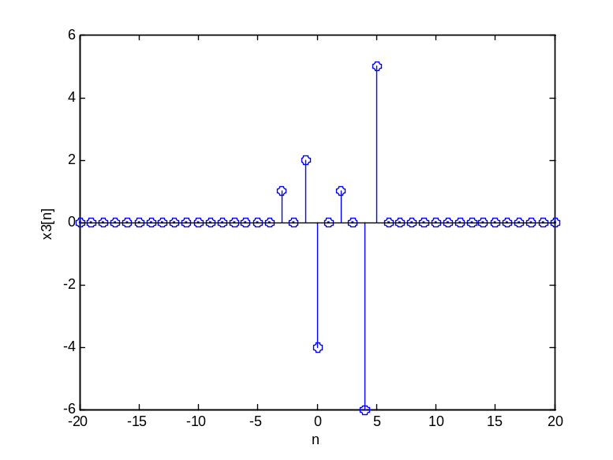

Zadatak 3.a)
______________________________________________________________________________________________________________________________________________________________________________________________________________________________________________________
syms t;  ezplot(2*cos(3*t)+  3*sin(2*t),[-3*pi,3*pi]); | 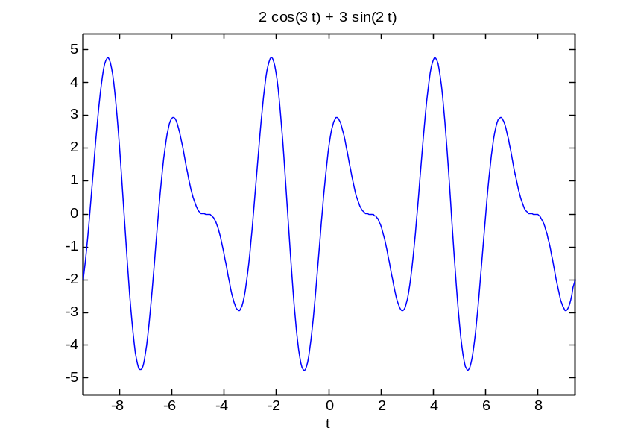

Zadatak 3.b)
______________________________________________________________________________________________________________________________________________________________________________________________________________________________________________________
syms t;  x=t*cos(t);  y=t*sin(t);  ezplot(x,y,[0,10*pi]); | 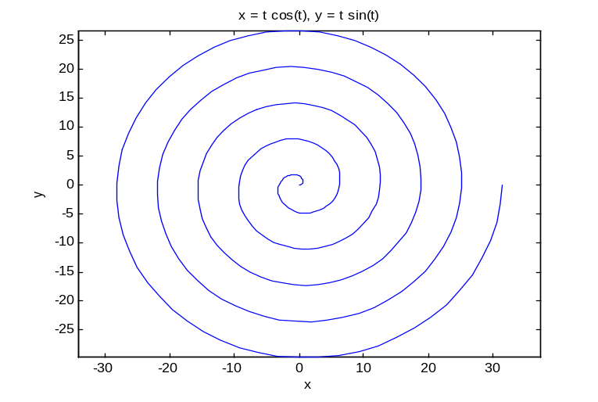

Zadatak 4.a)
______________________________________________________________________________________________________________________________________________________________________________________________________________________________________________________
Kod glavnog programa:  t=-3:0.01:4;  plot(t,x1(t));  Kod funkcije x1.m:  function y=x1(t)  for i=1:length(t)  y(i)=0;  if (t(i)>=0)&(t(i)<1)  y(i)=t(i);  end  if (t(i)>=1)&(t(i)<2)  y(i)=-t(i)+2;  end  end | 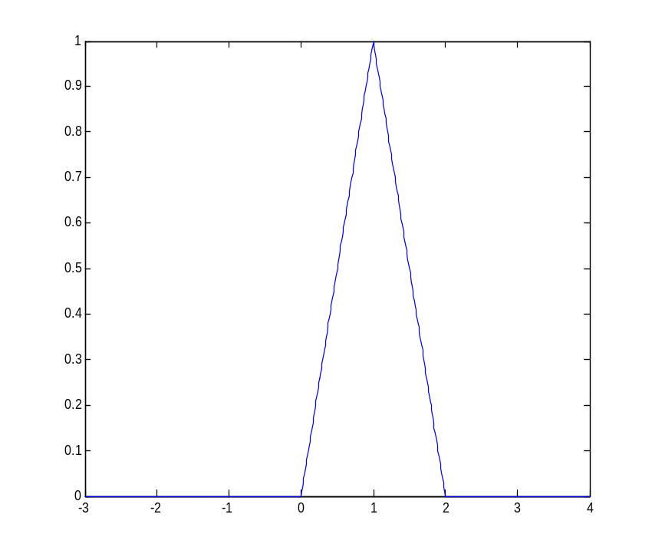

Zadatak 4.b)
______________________________________________________________________________________________________________________________________________________________________________________________________________________________________________________
Kod glavnog programa:  t=-3:0.01:4;  plot(t,x2(t));  Kod funkcije x2.m:  function y=x1(t)  for i=1:length(t)  y(i)=0;  if (t(i)>=-2)&(t(i)<-1)  y(i)=t(i)+2;  end  if (t(i)>=-1)&(t(i)<0)  y(i)=-t(i);  end  if (t(i)>=0)&(t(i)<1)  y(i)=t(i);  end  if t(i)>=1  y(i)=1;  end  end | 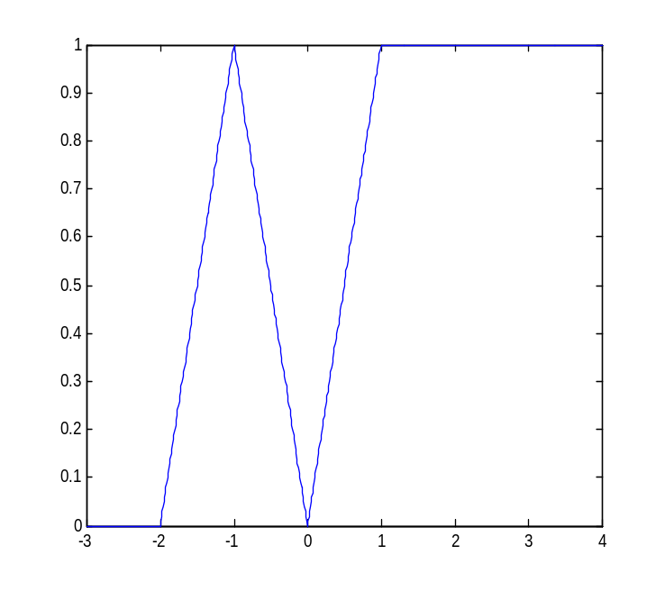

Zadatak 4.c)
______________________________________________________________________________________________________________________________________________________________________________________________________________________________________________________
Kod glavnog programa:  t=-3:0.01:4;  plot(t,x3(t));  Kod funkcije x3.m:  function y=x1(t)  for i=1:length(t)  y(i)=0;  if((t(i)>=0)&(t(i)<1.5))  y(i)=1;  end  if((t(i)>=1.5)&(t(i)<2))  y(i)=-0.5;  end  end | 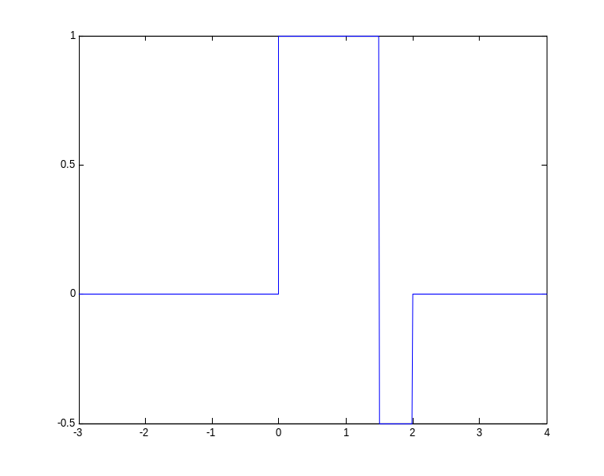

Zadatak 5.
______________________________________________________________________________________________________________________________________________________________________________________________________________________________________________________
t=-3:0.01:4;  par1=0.5*(x1(t)+x1(-t));  nep1=0.5*(x1(t)-x1(-t));  subplot(3,1,1);  plot(t,x1(t));  subplot(3,1,2);  plot(t,par1);  subplot(3,1,3);  plot(t,nep1);  figure(2);  par2=0.5*(x2(t)+x2(-t));  nep2=0.5*(x2(t)-x2(-t));  subplot(3,1,1);  plot(t,x2(t));  subplot(3,1,2);  plot(t,par2);  subplot(3,1,3);  plot(t,nep2);  figure(3);  par3=0.5*(x3(t)+x3(-t));  nep3=0.5*(x3(t)-x3(-t));  subplot(3,1,1);  plot(t,x3(t));  subplot(3,1,2);  plot(t,par3);  subplot(3,1,3);  plot(t,nep3); | Prvi signal: (signal a)  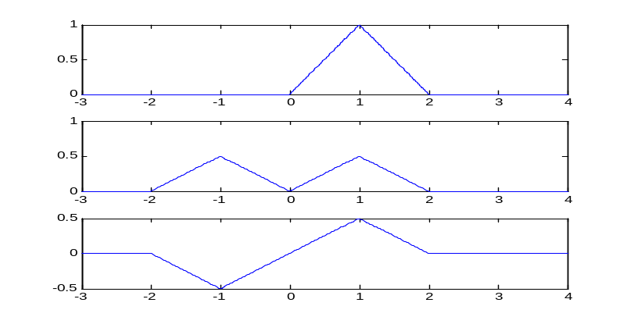  Drugi signal: (signal b)  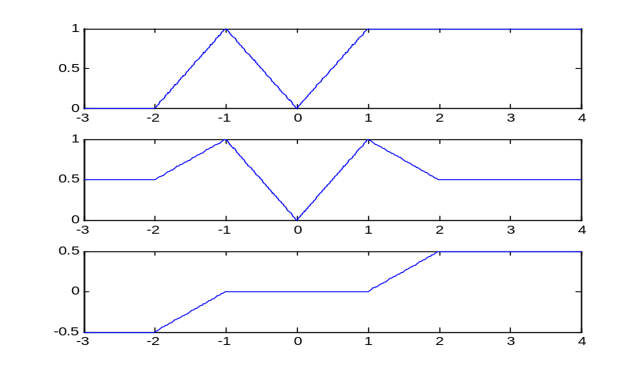  Treći signal: (signal c)  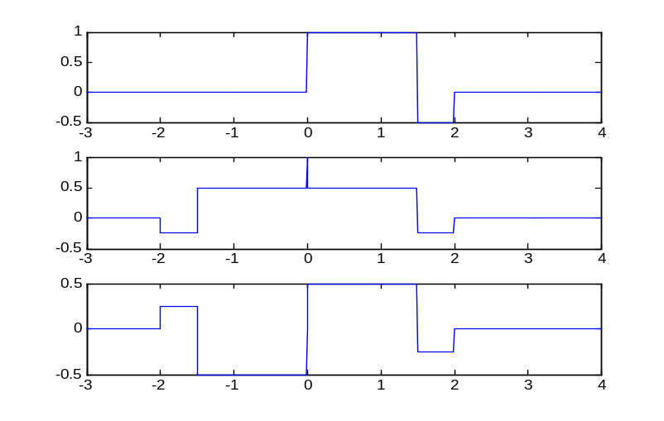

Zadatak 6.
______________________________________________________________________________________________________________________________________________________________________________________________________________________________________________________
t=-3:0.01:7;  a=x3(t);  b=x3(t-3);  c=x3(-t);  d=x3(t/3);  subplot(4,1,1);  plot(t,a); title('Originalni signal');  subplot(4,1,2);  plot(t,b); title('Pomak');  subplot(4,1,3);  plot(t,c); title('Obrtanje');  subplot(4,1,4);  plot(t,d); title('Skaliranje'); | 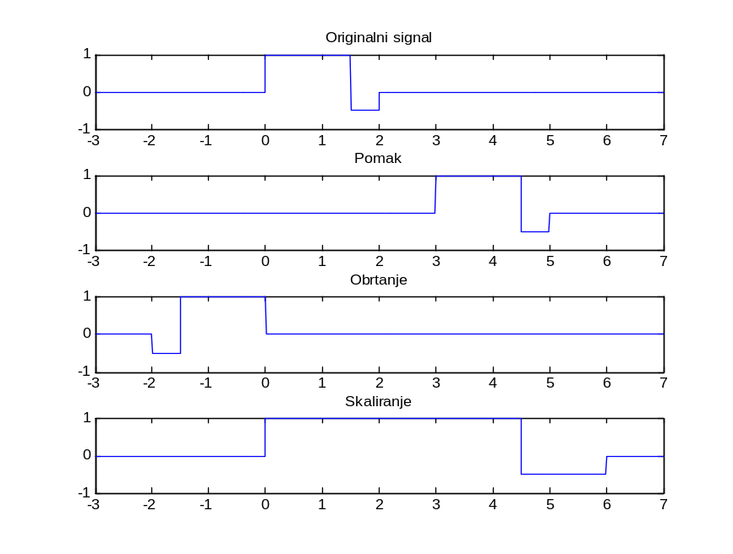

Zadatak 7.
______________________________________________________________________________________________________________________________________________________________________________________________________________________________________________________
t=-3:0.01:4;  a=x2(t);  b=x2(-3*t+2.5);  subplot(2,1,1);  plot(t,a); title('Originalni signal');  subplot(2,1,2);  plot(t,b); title('Signal s transformiranom vremenskom varijablom'); | 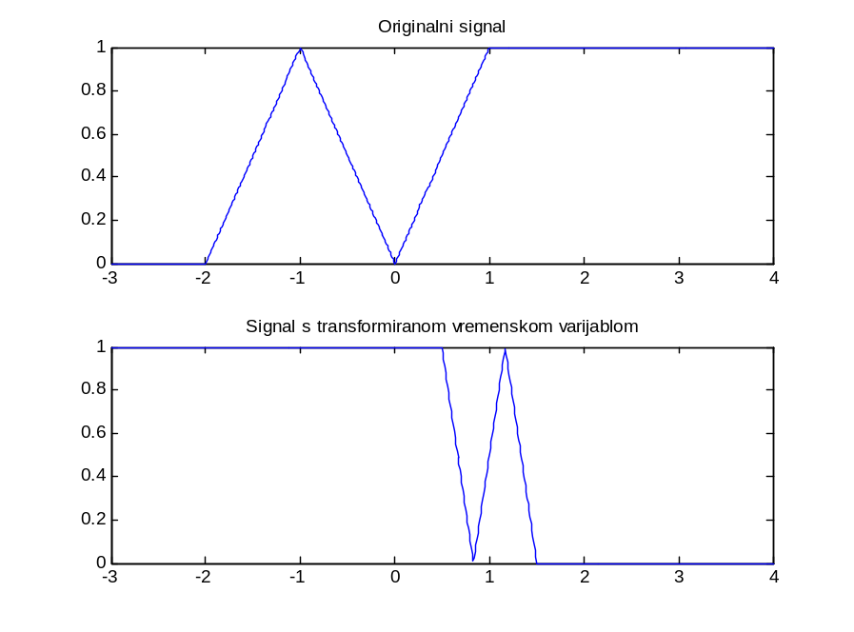

Zadatak 8.
______________________________________________________________________________________________________________________________________________________________________________________________________________________________________________________
n=-20:20;  subplot(4,1,1);  stem(n,x3n(n));  subplot(4,1,2);  stem(n,x3n(-n-5));  subplot(4,1,3);  stem(n,x3n(2*n+8));  subplot(4,1,4);  stem(n,x3n((n/3)-2)); | 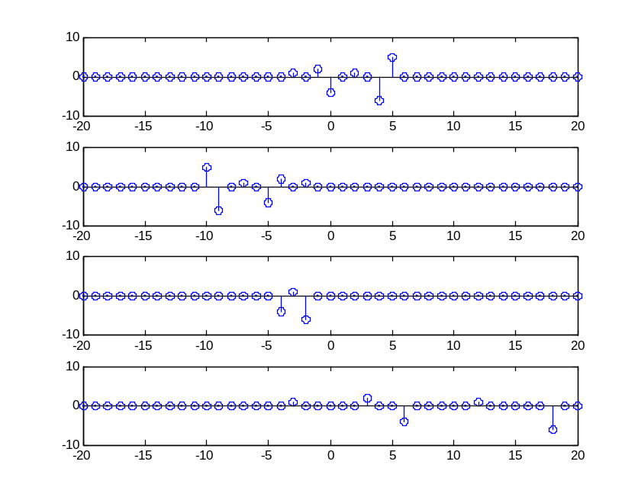

Zadatak 9.
______________________________________________________________________________________________________________________________________________________________________________________________________________________________________________________
n=0:30;  m=[1,5/2,6,8];  for i=1:4  x=cos((2*pi*m(i)*n)/7);  subplot(4,1,i);  stem(n,x);  end | 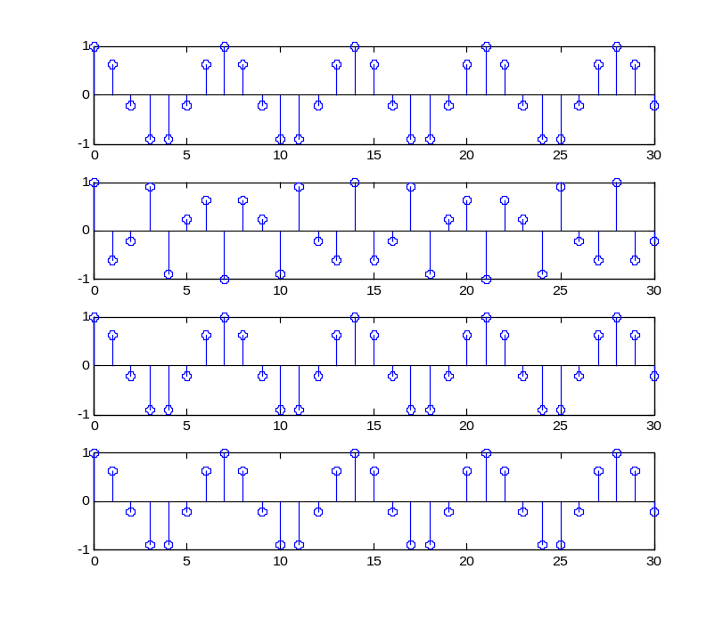

Zadatak 10.
______________________________________________________________________________________________________________________________________________________________________________________________________________________________________________________
t=-5:0.01:5;  K=[1 3 6];  for i=1:3  x=cos(((3*pi*t)/K(i))-(pi/4)).^2;  subplot(3,1,i);  plot(t,x);  end | 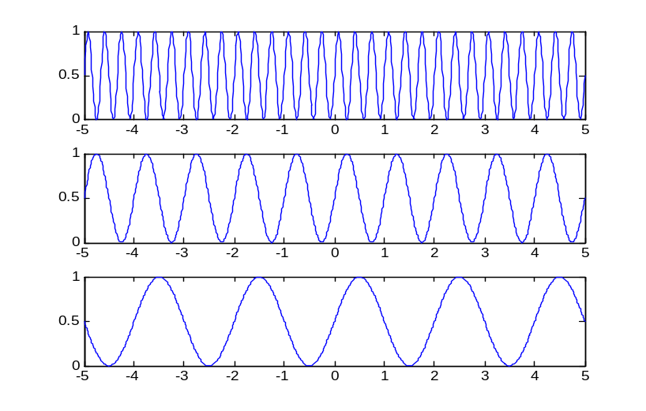

Zadatak 11.
______________________________________________________________________________________________________________________________________________________________________________________________________________________________________________________
n=0:40;  x1=2*sin(((3*pi*n)/4)+1/3);  x2=1.5*cos(n/7+pi/5);  x3=cos((pi*n)/4).*cos((pi*n)/8);  x4=3*cos((pi*n)/8)+2*sin((pi*n)/2)-4*sin((pi*n)/4);  subplot(4,1,1);  stem(n,x1);  subplot(4,1,2);  stem(n,x2);  subplot(4,1,3);  stem(n,x3);  subplot(4,1,4);  stem(n,x4); | 